1. The project schedule indicates what needs to be done, which resources must be utilized and when the project is due.

2. Network diagram is the graphical representation of tasks, and work flow for a project. It is used to map the schedule and work sequence of the project keeping a track of its progress.

Network contains two major components :-

* Activities : An activity represents an action and consumption of resources.

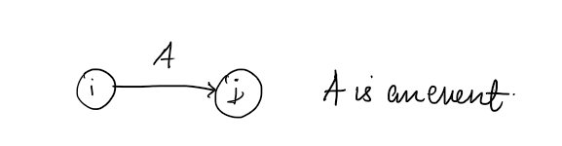

* Event : An event will always ooccur at the beginning and end of an activity. It does not have a source.  
  